ECS795P Deep Learning and Computer Vision, 2024
Coursework 1: Building a Transformer from Scratch

- The calculation formula for self-attention is as follows. Assuming the input X has dimensions [768, 6], and $W^{Q}$, $W^{K}$ and $W^{V}$ all have dimensions [768, 768], calculate the dimensions of K, Q, V, and the output of Attention(Q, K, V). (10% of CW1) 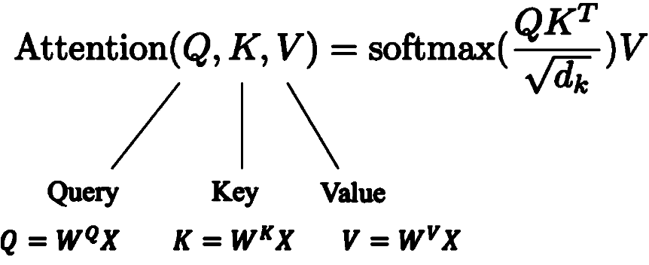

- 1) How is the self-attention mechanism implemented?
2) What are the primary applications of self-attention? (mention 3 points)
3) What advantages does transformer have compared to CNN? (10% of CW1)

- Answer the following questions based on the code:
1) In the section “From attention to transformers - Multi-head attention”, what are the shapes of the following variables: tokens, qis_mh, kis_mh, vis_mh, attmat_mh, zis_mh, zis?
2) In the 'Classification' section, plot the curves of classification accuracy and loss as they vary with epochs for three different settings: 10 epochs, 30 epochs, and 50 epochs. (10% of CW1)

